5-Ingredient Sweet Potato Brownies

Ingredients
300g sweet potato
125g nut butter of choice
70g maple syrup
25g Organic Cacao Powder
A crack of sea salt
A handful of chocolate chips (optional)

Method
Preheat the oven to 175¬∞C.
Bring a saucepan of water to boil. Peel and chop sweet potatoes and steam for 15-20 minutes.
Mash sweet potato and transfer to a mixing bowl. Add the nut butter, maple syrup, cacao powder, and a crack of salt.
Mix all ingredients until you have a smooth brownie batter.
Transfer the batter to a lined loaf tin or baking dish, sprinkle with chocolate chips if using them, and bake for 20 minutes.
Remove from the oven and leave to cool before slicing into ten pieces.

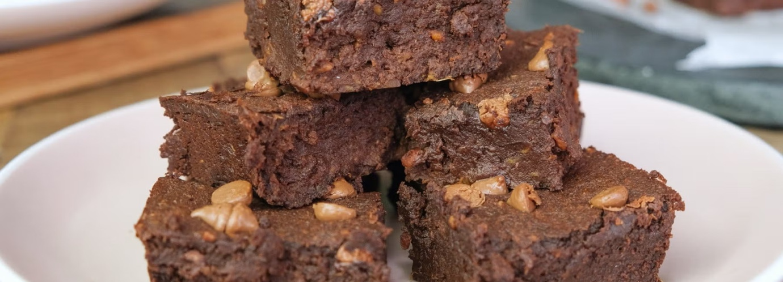https://www.myprotein.com/thezone/recipe/5-ingredient-sweet-potato-brownies/

Mary Berry's lemon meringue cupcakes

Ingredients

For the sponge
- 100g/3½oz baking spread or softened unsalted butter
- 150g/5½oz self-raising flour
- 150g/5½oz caster sugar
- 3 tbsp full-fat milk
- 2 free-range eggs
- 1 unwaxed lemon, finely grated zest only
- 7g freeze-dried strawberries (available in large supermarkets), to decorate

For the filling
- lemon curd

For the meringue
- 2 free-range egg whites
- 100g/3½oz caster sugar
How-to videos

Method
- Preheat the oven to 180C/160C Fan/Gas 4. Line a 12-hole muffin tray with cases.
- Put the sponge ingredients into a bowl and whisk using an electric hand whisk until light and fluffy.
- Spoon the mixture evenly between the cases. Bake for 18–20 minutes or until golden-brown, risen and springy to the touch. Set aside to cool completely.
- Cut a deep circle in the centre of each cake (about the width of a £2 coin) and pull out a walnut size of sponge to leave a hole. Spoon 1 teaspoon lemon curd into each hole, making sure the curd is level with the top.
- To make the meringue, whisk the egg whites in a large bowl with an electric hand whisk until stiff. Gradually add the sugar as you continue whisking on full speed, until you have a stiff glossy mixture.
- Use a palette knife to spread (or use a piping bag to pipe) the meringue on the top of each cupcake and sit back in their tins.
- Use a chef’s blowtorch to brown the meringue or slide the tray under the grill. Watch carefully and remove when golden-brown.
- Sprinkle with the freeze-dried strawberries and serve.
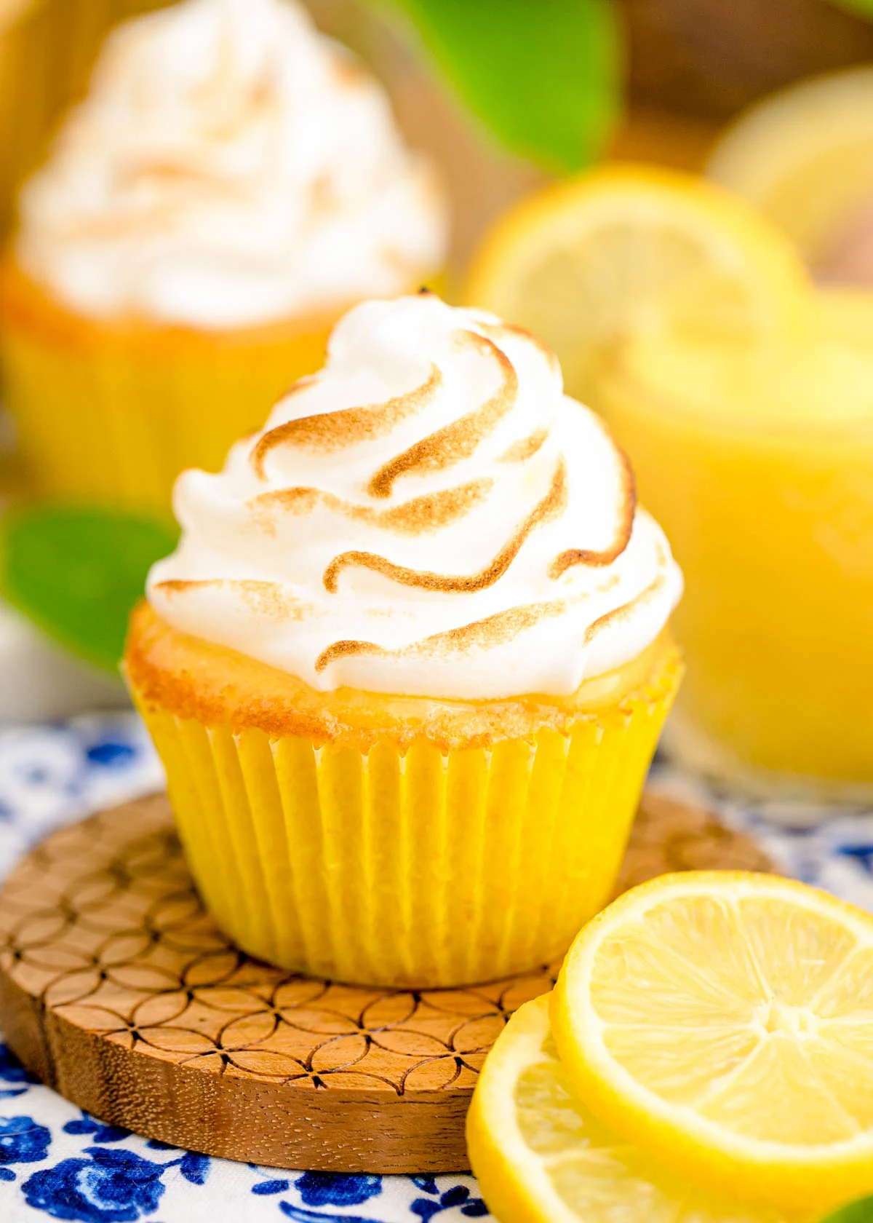

https://www.bbc.co.uk/food/recipes/lemon_meringue_cupcakes_41613

Classic scones with jam & clotted cream

- 350g self-raising flour plus more for dusting
- 1 tsp baking powder
- 85g butter cut into cubes
- 3 tbsp caster sugar
- 175ml milk
- 1 tsp vanilla extract
- squeeze lemon juice
- beaten egg to glaze
- jam and clotted cream to serve

Method
- Step 1
Heat the oven to 220C/200C fan/gas 7. Tip the self-raising flour into a large bowl with ¼ tsp salt and the baking powder, then mix.
- Step 2
Add the butter, then rub in with your fingers until the mix looks like fine crumbs. Stir in the caster sugar.
- Step 3
Put the milk into a jug and heat in the microwave for about 30 secs until warm, but not hot. Add the vanilla extract and a squeeze of lemon juice, then set aside for a moment.
- Step 4
Put a baking tray in the oven. Make a well in the dry mix, then add the liquid and combine it quickly with a cutlery knife – it will seem pretty wet at first.
- Step 5
Scatter some flour onto the work surface and tip the dough out. Dredge the dough and your hands with a little more flour, then fold the dough over 2-3 times until it’s a little smoother. Pat into a round about 4cm deep. Take a 5cm cutter (smooth-edged cutters tend to cut more cleanly, giving a better rise) and dip it into some flour. Plunge into the dough, then repeat until you have four scones. You may need to press what’s left of the dough back into a round to cut out another four.
- Step 6
Brush the tops with a beaten egg, then carefully arrange on the hot baking tray. Bake for 10 mins until risen and golden on the top. Eat just warm or cold on the day of baking, generously topped with jam and clotted cream. If freezing, freeze once cool. Defrost, then put in a low oven (about 160C/140C fan/gas 3) for a few minutes to refresh.

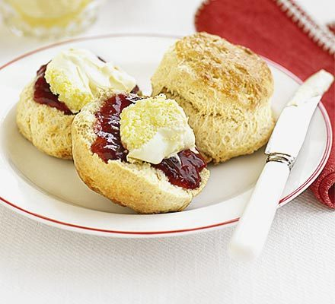
https://www.bbcgoodfood.com/recipes/classic-scones-jam-clotted-cream

Roasted Salmon with Mustard and Tarragon

Ingredients
- 1/4 cup mayonnaise
- 1 Tbs. plus 1 tsp. coarse-grained Dijon mustard
- 2 tsp. fresh lime juice
- 2 tsp. finely chopped fresh tarragon
- 6 6-oz. center-cut, skin-on salmon fillets
- Kosher salt

Nutritional Information

Preparation
- Position a rack in the centre of the oven and heat the oven to 200°C. Line a heavy-duty rimmed baking sheet with foil.
- In a small bowl, stir together the mayonnaise, mustard, lime juice, and tarragon. Arrange the salmon skin side down on the baking sheet and sprinkle lightly with salt. Spread the mayonnaise mixture evenly over each fillet (there may be a little left over).
- Roast the salmon until just cooked through, 10 to 14 minutes.
- Using a spatula, lift the fillets off the baking sheet, leaving the skin behind, and transfer to plates.
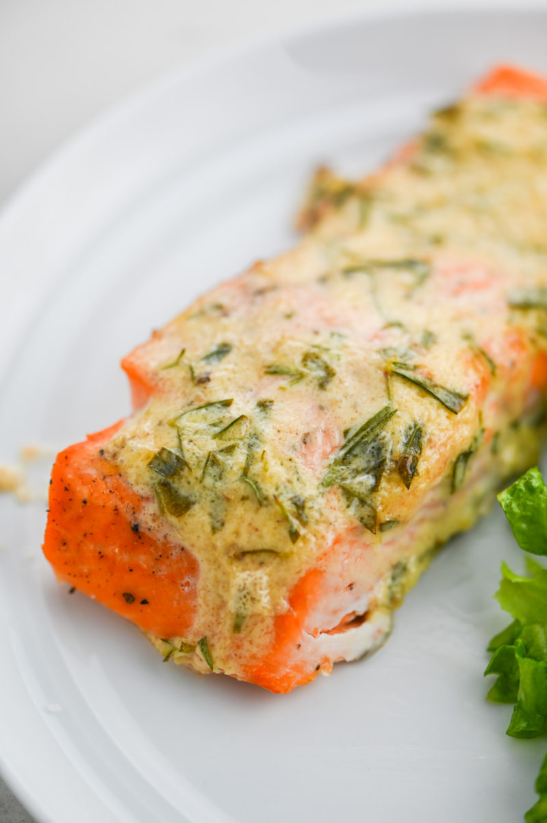

https://m.lestubes.com/recipe/roasted-salmon-with-mustard-and-tarragon

Cheesymite Scrolls

Ingredients
CupsMetric

DOUGH:
- ▢ 600 g bread flour , substitute plain/all-purpose flour (Note 1)
- ▢ 9.3 g instant yeast (rapid-rise yeast) (Note 2)
- ▢ 2 tsp white sugar
- ▢ 1.25 tsp cooking salt (kosher salt), halve for table salt
- ▢ 405 ml warm milk (full or low fat) (Note 3)

VEGEMITE & CHEESE:
- ▢ 50 g salted butter , softened
- ▢ 3 tbsp Vegemite (Note 4)
- ▢ 500 g Colby cheese , freshly shredded (or cheddar, Monterey Jack) (Note 5)
Cook ModePrevent screen from sleeping

Instructions
- Mix flour, yeast, sugar, and salt. Add milk and knead (or mix with dough hook) for 5 minutes until smooth.
- Form into a ball, cover, and let rise in a warm place for 1½ hours until doubled in size.
- Punch down the dough, lightly flour the surface, and roll into a 48 x 28 cm / 11 x 19” rectangle.
- Spread with butter, then Vegemite, then evenly cover with 300g cheese.
- Roll into a log, cut into 12 even pieces, and place into a greased and lined 23 x 33 cm / 9 x 13” pan.
- Cover lightly and let rise again for 30 minutes, until expanded by roughly 30–50%. Top with remaining cheese.
- Bake at 180°C/350°F (160°C fan) for 25 minutes, rotate the pan, then bake another 10 minutes at 200°C/375°F (180°C fan) until golden. Cool 10 minutes total before serving warm.
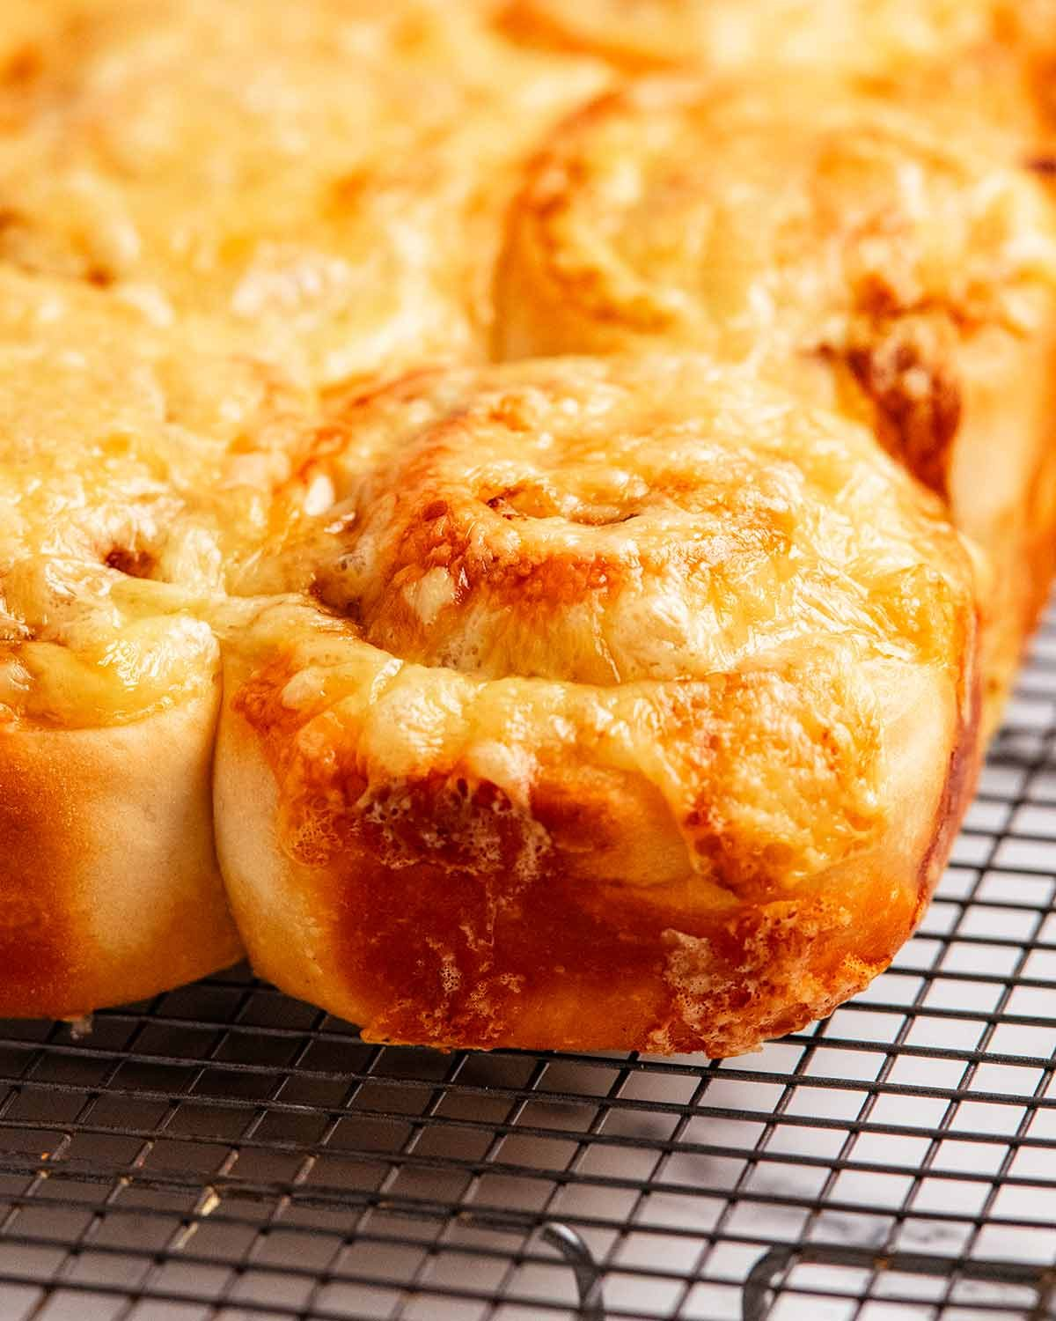
https://www.recipetineats.com/cheesymite-scrolls/

QUICK SALMON FISHCAKES

INGREDIENTS
1 stick of lemongrass
6cm piece of ginger
½ a bunch of fresh coriander (15g)
500g salmon fillets, skin off, pin-boned, from sustainable sources
4 teaspoons chilli jam

METHOD
- Whack the lemongrass against your work surface and remove the tough outer layer.
- Peel the ginger, then very finely chop with the inside of the lemongrass and most of the coriander, stalks and all, reserving a few nice leaves in a bowl of cold water.
- Chop the salmon into 1cm chunks over the mix on your board, then push half the salmon to one side.
- Chop the rest until super-fine, almost like a purée, then mix the chunkier bits back through it and season with sea salt and black pepper.
- Divide into 4, then shape and squash into 2cm-thick patties.
- Place a large non-stick frying pan on a medium-high heat with 1 tablespoon of olive oil.
- Cook the patties for 2 minutes on each side, or until nicely golden.
- Spoon the chilli jam over the fishcakes, add a splash of water to the pan, turn the heat off, and jiggle to coat.
- Serve sprinkled with the drained coriander.

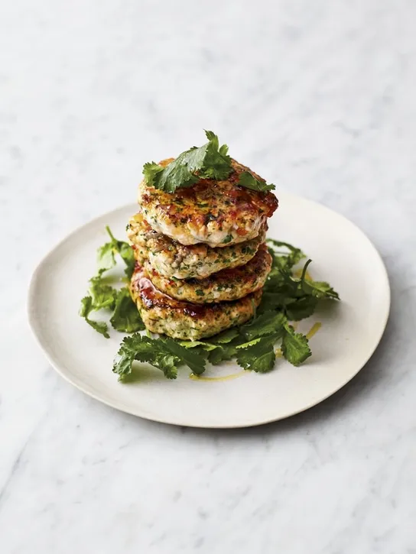
https://www.jamieoliver.com/recipes/salmon/quick-salmon-fishcakes/

Amaretti biscuits

Ingredients
- 4 eggs, whites only (160g/6oz)
- 340g/12oz caster sugar
- 340g/12oz ground almonds
- 30ml/1fl oz amaretto liqueur
- butter, for greasing

Method
- Preheat the oven to 170C/325F/Gas 3.
- In a large bowl beat the egg whites until firm. Mix the sugar and the almonds gently into it. Add the amaretto liquor and fold in gently until you have a smooth paste.
- Place some baking paper on a baking tray and lightly brush with butter. Using a teaspoon place small heaps of the mixture approximately 2cm/¾in apart, as they will expand while cooking. Bake for approximately 15 minutes until golden brown. Leave to cool slightly then serve or store in an air-tight container.

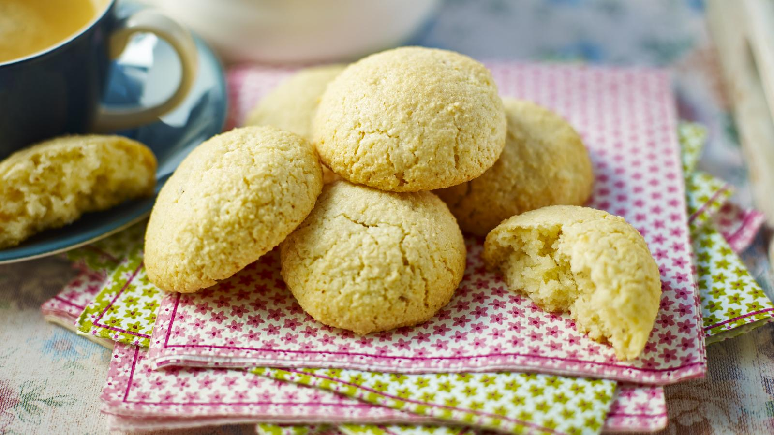
https://www.bbc.co.uk/food/recipes/amarettibistcuits_67183

